Spa Cover Colors

Light Gray

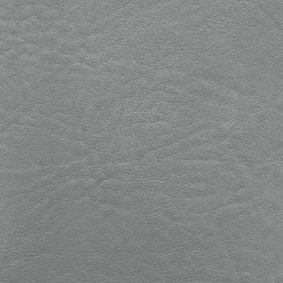

Dark Gray

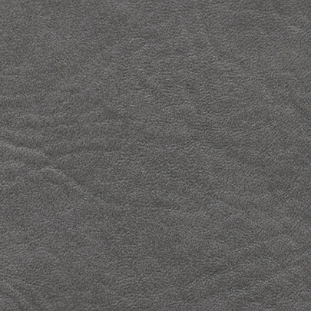

Dark Blue



Light Blue



Mahogany

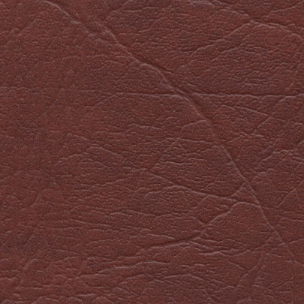

Palomino

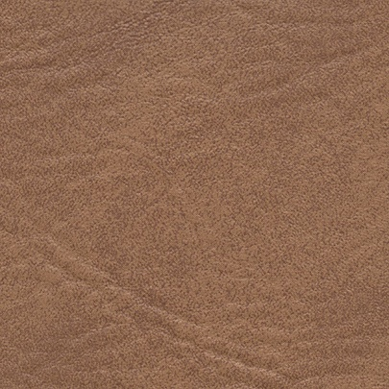

Black

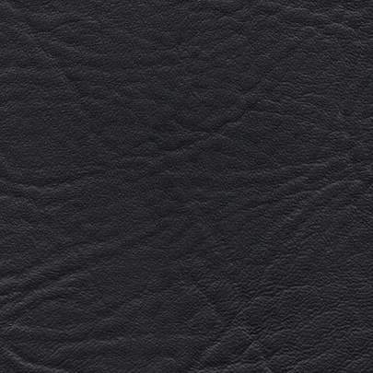

Burgundy

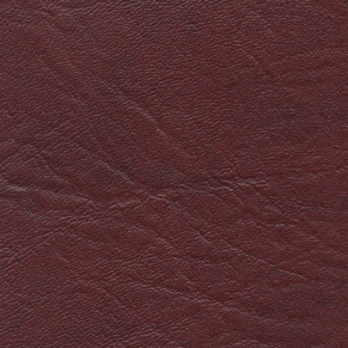

Forest Green

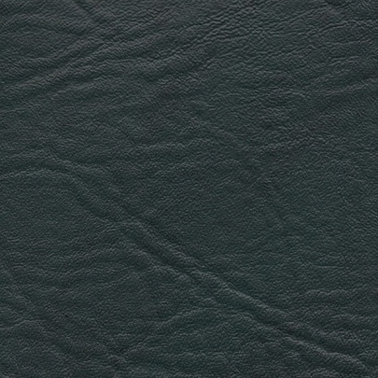

Teal

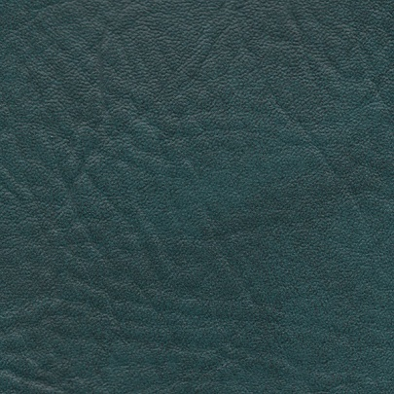

Parchment

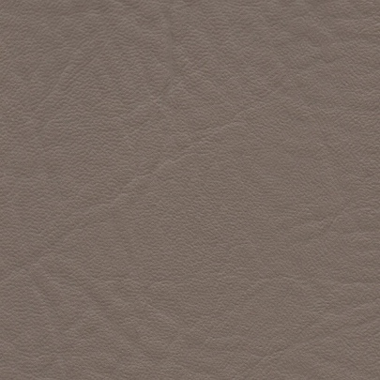

Almond

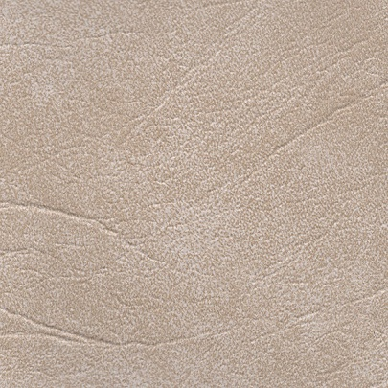

Dark Brown

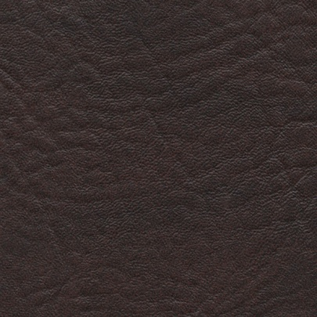

**Color Disclaimer:**  
Colors may be different than displayed here for numerous reasons,  
including but not limited to:  
DISTORTION IN RENDERING BY YOUR VIDEO CARD  
DISTORTION IN DISPLAY BY YOUR MONITOR  
DYE LOT SHADE CHANGES